The Many Different Views on Creation
Theoretical – Differing views of creation have existed for ages ranging from the literal to the allegorical. The concerns over creation have also differed through time. While historic concerns related to God’s nature and relationship to the world are crucial to biblical Christianity, contemporary concerns related to when and how God created are ancillary.
Practical – Since understanding when and how God created the world is not necessary for salvation, Christians should not question the salvation of others for holding different views and should be charitable in the face of disagreement.
The Historic Concern
Regarding creation, the predominant concerns of the Church until the 18th/19th Century had nothing to do with when or how God created the universe. The Church and theologians were more primarily concerned with:
1) Metaphysical Status: What is the nature of the universe and God’s relationship to it. Whether God created the universe “out of nothing” (ex nihilo), from a preexisting material (Gen 1:2a – “the earth was without form & void”), or the universe is part of or inside God. Debates raged over the logical possibility of the universe being eternal instead of having a clear “beginning” brought about by God. Non-ex nihilo views of the universe typically diminish or deny one of God’s biblical attributes, many of which are essential to the salvation narrative. These views typically include:
Monism – The universe consists only of one substance. In Emanationism, the universe is the “overflow”/effect of God. In Pantheism, the universe is God. Denies God’s immutability, holiness, and distinct personhood (& human personhood).
Dualism – The universe always coexisted alongside God. OR there is an equal and oppose reality opposed to God: good vs. evil (Zoroastrianism or Manicheanism). Denies God’s aseity, and his guaranteed victory over evil.
Necessarianism – The universe emanates/flows from God by his nature or God needed to create (e.g. in order to love). Denies that God freely chose to create, or the immutability & perfection God prior to creating the world.
Materialism – The universe consists only of matter/waves/particles according to natural laws. Hence, it operates mechanistically and its existence is either a “brute fact” or a product of chance. Denies God’s existence.
2) Moral Status: Whether the universe is intrinsically good or fallen. God created the world and called it “good”, but it has been invaded by sin so physical bodies & natural processes are afflicted with death, disasters, decay, and evil. These views can be seen in Hymns: “This is My Father’s World” vs. “This World Is Not My Home (I’m Just a-Passin’ Through).”
Good – The world is humanity’s home that God will redeem. Focus on God’s original blessing of his presence.
Fallen – The world is merely a series of trials (like purgatory) necessary to enter Heaven. Focus on sin nature.
Good & Fallen – The world is good but NOT God and good but fallen under a curse.
Christian Consensus on Creation
Despite all the disagreement over Creation, Christians are largely in agreement over four claims:
1) God is the source of all that there is
2) creatures are dependent yet real and good
3) God creates in freedom and with purpose
4) Creation is fallen under a curse and needs supernatural healing (i.e. redemption).
The Contemporary Concern
Much of the current debate over creation is not about creation at all, but authority. It is claimed that the authoritative discipline comes “first” and shapes the subsequent disciplines, and thus for Christians to put anything before their interpretation of the Bible is a denial of Scripture’s authority and its truths including those pertaining to salvation.
“Science First” Methods
Gap Theory – In the 18th Century, when scientific evidence of long geological eras emerged, an undetermined period of time was postulated in-between Genesis 1:1 (when God created the world ex nihilo) & 1:2 (when earth was restored). In this “gap” Lucifer and his angels fell (Isa. 14:13-14; Ez. 26:14; 2 Peter 3:5-6) triggering God’s judgement in the form of a flood (“Lucifer’s Flood”) as evidenced by 1:2b, 9-10 (“And the Spirit of God moved upon the face of the waters”). Hence, earth was millions of years old & filled with fossils created during Lucifer’s Flood before the seven days of re-creation.
Day-Age Theory – The Hebrew word for “day” is yom, which typically refers to a 24-hour period. However, yom can also refer to an indefinite duration of time: Gen. 2:4b; Ps. 90:4; & Isa. 4:2. Each “day” in the creation account refers to an era or epoch lasting a long time. Since Gen 1 is poetic, “morning and evening” is understood as the dawning and closing of each age. Hence, God could have created animals according to their “kinds” early on the sixth “day” and Man later on the sixth “day”. “Progressive Creationism” sometimes refers to this view.
Apparent-Age Theory – To try and reconcile science with Scripture it is presumed God created a universe that looked old, that is God created an old universe on Day 1. It is argued that since Adam was not created as baby, but as a full-grown man, then similarly the universe could have come into existence at a mature age. Hence, the world was created complete with geological layers, fossils, carbon dating, and even light in “transit”. Speculation? Is God dishonest or a prankster?
Punctuated 24-Hour Theory – Evidence for an old earth is combined with literal 24-hour days of creation. In between each creation day in Genesis is a geological era lasting millions of years. Hence, God created the heavens and the Earth on the first 24-hour period, but millions of years passed before God created again on the second 24 hour period. Each day is thus followed by millions of years. During these millions of years between 24 hour periods of creation, nature would “take its course” giving the universe its age. “Progressive Creationism” sometimes refers to this view.
Theistic Evolution/“BioLogos”/Evolutionary Creationism – Following Darwin’s Origin of Species published in 1859, God is seen as maintaining full control of an evolutionary creation process by guiding the natural development of species through millions of years. Many mythologize Genesis 1 arguing that the names like “Adam” (אדמ) are plays on words like “earth/dust” (אדמה). Hence, creation of the first humans can be seen as the “adoption”/“election” of two evolved primates by bestowing the image of God on them; the Fall brought about not physical death, but spiritual death; etc. “The idea that all death and suffering and ‘natural evil’ of any sort are the result of a primal sin act is based on a relatively recent interpretation of the Bible’s story that mis-reads several verses in Romans and applies certain assumptions of what “very good” creation is supposed to look like” (BioLogos). Evolution is not driven by a secular, worldly agenda, but sound science. God’s intelligence and purposeful design in nature does not require that He interrupt the course of nature.
Microevolution: Genetic mutation/change within a species or small group of organisms over a short period; “adaptation”
Macroevolution: Microevolution extrapolated to whole taxonomic groups (interspecies) over long periods of time
Intelligent Design – A position and movement historically advocated by the Discovery Institute (a US conservative political think-tank) that emerged in response to judicial defeats to teach creationism in US schools. Draws on William Paley’s “watchmaker” analogy: "Wherever complex design exists, there must have been a designer; nature is complex; therefore, nature must have had an intelligent designer." Rests on three propositions: 1) Evolution promotes an atheistic worldview; 2) evolution cannot account for the complexity of nature; 3) evolution cannot explain irreducible complexity.
Irreducible complexity: a system of parts necessary to a basic function which cannot be removed w/o ruining the system.
Scientific Creationism – Alternative hypothesis have been put forth claiming science itself demonstrates the world is young (typically between 7,000-15,000 years old). A commonly cited theory is “Flood Geology” which claims the various strata/layers in the earth's crust were caused not by millions of years of tectonic changes and the natural weather cycle, but by Noah's flood. It is proposed that a world-wide flood would have caused intense global pressure to account for the geological data. Hence, the world is young and there is no conflict with a literal 24-hour rending of Genesis 1.
Key Sources: https://www.blueletterbible.org/faq/creation.cfm
http://biologos.org/blogs/brad-kramer-the-evolving-evangelical/5-common-objections-to-evolutionary-creationism
“Bible First” Methods –
24-Hour Interpretation – The most traditional interpretation based on a “straight-forward” reading of the text. Holds that God created the universe in six Earth solar days. “Day” simply means “day” as reinforced by the constant refrain of “evening and morning.” Genesis 1:1 is then taken as a summary of the gradual creation process. It is argued that God created the world in 7 days so humans could relate through a typical week. BlueLetterBible: “One of the interpretation's strongest arguments is one from silence: while a figurative interpretation of the Creation Days is not impossible, it is believed entirely unmerited, for nowhere does Scriptural discussion of the Creation indicate or support any sort of figurative rendering.” With tradition and simplicity on its side, the burden of proof rests with non-24 hour interpreters.
Objections:
- The sun dictates a 24 hour Earth day, but was not created until day four making a 24 hour days meaningless
- It is possible that Genesis 1:1 is not a summary, but an event preceding day one
- An argument from silence is insufficient to deny the days may be interpreted figuratively
- The Genesis 2 creation account has a different order of creation without days
- Sabbath day is eternal because “then there was evening and morning the Xth day" is used for all but the 7th day
Historical Creationism - The universe was created in Genesis 1:1, and the creative days refer to the preparation of the garden of Eden for God’s people. The original Hebrew words have a larger semantic range that can be translated with a smaller scope: “Heaven” vs. “Sky”; “Earth” vs. “land”; “formless and void” vs. “uninhabited wasteland”. Hence, creation in Gen 1:1 occurred at a time irrelevant to Gen 1:2-2:3. Sees other interpretations as the result of either scientific or religious influence and that the view has been overlooked due to unfortunate translation choices in the KJV.
Objections: There is little textual evidence of translations using “historic” meanings & few scholars support this view
Framework Theory Interpretation – The Creation Week is a literary structure that reveals what was created and its relation to the rest of creation, but not when it was created. While God’s acts and claims (i.e., "Then God said, 'Let there be light'; and there was light") are historical events that actually happened, they are presented in a framework of days to demonstrate the theological truths of covenant promises and the role of the Sabbath. No chronological implications are seen in the text, and argues against a literary 168-hour sequence. Days 1-3 present the creation of “kingdoms” or realms.
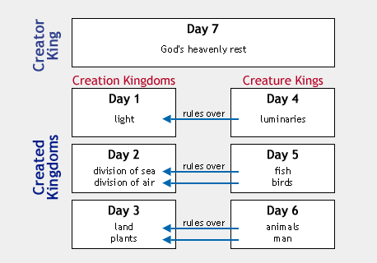Days 4-6 present the creation of “movers” or “kings” which occupy and rule over the kingdoms/realms created in days 1-3.
Humans, the last thing created, ae “king” or rulers over all other creation (Gen 1:26, 28, & 2:5).
All realms are then under God’s dominion (the ultimate King) who created all and rested on the 7th day.
BlueLetterBible: “Beside literary support (in the form of parallelism between Days One and Four, the chiastic nature of Days Two and Five, and dischronologization throughout), the Framework Interpretation applies God's seeming use of ordinary providence in Genesis 2:5-6 to demonstrate that such providence is likely active throughout God's creation of the universe.”
Objections:
- In the 10 Commandments, the 4th commandment seems to invoke 24 hour days (Exodus 20:8-11)
- The interpretation requires a less straight-forward reading of the text
- While the days are non-literal & non-sequential for theological purposes, 24 hour period creation is not ruled out
Creation as Cosmic Temple – The creation account uses temple imagery to present theological truths about God’s relationship to his creation. Creation is both the temple and the holy of holies. In the first account, God’s power, glory, and transcendence are emphasized, and God’s tenderness, relationship orientation, and proximity in the second.
First account (Genesis 1:1-2:3)
- He is “Elohim” (Deity)
- God creates by speaking
- God portrayed as a King
- God portrayed as beyond
Second account (Genesis 2:4-25)
- He is YHWH (His name)
- YHWH creates with His hands
- YHWH portrayed as a Father
- YHWH portrayed as near
Creation & Eden | Tabernacle/Temple & Holy of Holies
Six days of creation (“and God said…”) and finishing with the seventh day of rest (Gen 1:1-31) | Seven commands from God (“and YHWH said to Moses saying…”) on the construction of the tabernacle (Ex. 25:1; 30:11, 17,22,34; 31:1, 12) finishing with the command of the sabbath (31:12-17)
Spirit of God hovering over the waters (Gen. 1:2), supervising creation | Spirit of God empowers Bezalel to create the artistry of the Tabernacle and the Holy of Holies (Ex. 31:1-3)
Tree of Life in the garden of Eden (Gen 2:9) | The lampstand is fashioned like a tree inside the Holy place (Ex. 25:31-36)
Cherubim are posted to guard the entrance to garden of Eden (Gen. 3:24) | Cherubim are embroidered on the curtain separating the Holy of Holies from the rest of the Tabernacle (Ex. 26:31)
Further evidence of a pattern in creation and the temple:
(1) The Tabernacle and the Sabbath are connected to each other. See Leviticus 19:30 and 26:2, “You shall keep my Sabbaths and venerate my Sanctuary” (Sarna).
(2) The Tabernacle is assembled on New Year’s day (Exod 40:17) which represents the Creation symbolically (Sarna).
(3) In the Ancient Near East, the cosmos was regarded as a sort of temple for the gods and temples were associated with the cosmos (Walton, The Lost World of Genesis One)
(4) There are specific elements of cosmos/Creation in the Tabernacle/Temple (Walton):

…The Laver . . . . . . . . . . . . . . The Waters
…The Pillars . . . . . . . . . . . . . .The Pillars of the Earth
…The Menorah . . . . . . . . . . . The Heavenly Lights
…The Bread . . . . . . . . . . . . . .Vegetation
…The Incense . . . . . . . . . . . . The Cloud
…The Veil . . . . . . . . . . . . . . . .The Firmament (Sky)

(5) Isaiah 66:1-2: “The heaven is My throne, and the earth is My footstool: Where could you build a house for Me? What place could serve as My abode? All this was made by My hand. And thus it all came into being — declares the LORD.”
(6) In the second Creation account, the rivers of Eden become a Temple theme. Thus, waters will come from the Temple giving life in the New Earth as in Ezek 47:1-12; Psa 46:5(4); Zech 14:8; Rev 22:1-2 (Walton).
Objections:
- Documentary hypothesis theory does not see the same author for both of these texts
- Scripture does not explicitly point to this parallelism or pattern
- Finding specific symbolisms for each day of Creation can be overdrawn, or stretch hermeneutical credibility
See: John Walton’s book: The Lost World of Genesis One: Ancient Cosmology and the Origins Debate
Nahum M. Sarna’s commentary: The JPS Torah Commentary: Exodus

Exegetical Themes & Considerations
Author: Moses is traditionally seen as the primary author of the first five books (“Pentateuch”) of the OT (some verses strongly suggest a later editor compiled the final canon version). Moses had access (witnessed the accounts first hand), had the necessary education (he was raised by Pharaoh’s daughter in Egypt), and the time (40 years in the wilderness).
Documentary Hypothesis theory suggests the Pentateuch has four underlying sources: J (for Jahweh/Yahweh- the personal name of God), E (for Elohim the generic name for God), D (for Deuteronomy), and P (for Priestly).
Audience: Assuming Mosaic authorship, the audience would have been the Israelites who made the exodus from Egypt into the wilderness and their direct descendants. Thus, it is important to consider the context of the original audience.
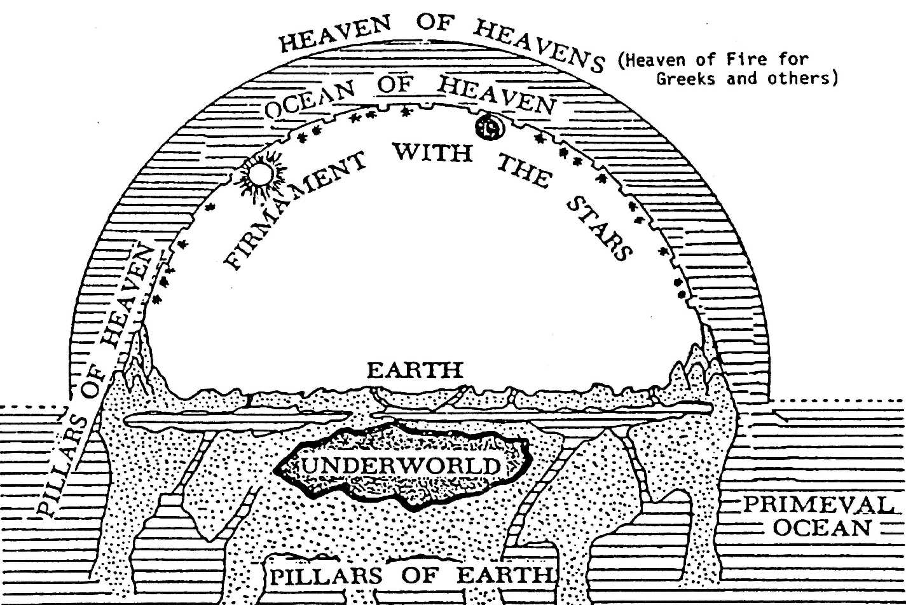
Cosmology – Genesis alludes to the Ancient Near East’s (ANE) three-part world, with the heavens above, earth in the middle, and the underworld (sheol) below. The cosmos was a watery chaos and separating the waters created a “bubble” within the waters. The waters above were held at bay by the firmament or the dome of heaven. The firmament was seen as a solid dome, which was spread or beaten out (verb raqia' is usually used with metals). The Sumerians believed the heaven sky-vault was literally made of metal. The ancient Egyptians held that the sky was a roof supported by pillars, holding back the watery chaos from all sides.
Other Creation Accounts: Genesis is not the earliest known creation account. Most ancient creation accounts depict one god overcoming other gods or fierce/powerful beast (usually representing disorder). The cosmic champion then fashions the known world and is proclaimed by the other gods to be the divine “king” over ordered creation (fighting disorder).
Babylonian Enuma Elish: Two gods, Apsu (fresh waters) and Tiamat (ocean waters), are annoyed by the babel (noise) of young gods and Apsu wishes to kill them. The gods take sides and a war ensues. Marduk’s father kills Apsu. The gods inside Tiamat, annoyed with Marduk, convince her to avenger her dead husband Apsu. She creates 11 monsters (of which include: “Venomous Snake”; “Great Dragon”; “Exalted Serpent”; “Furious Snake”). Marduk offers to save the gods if he is appointed as their leader and they accept, naming him their champion. Marduk kills Tiamat and rips her corpse into two halves to fashion the earth and the skies. Marduk then provides orders: the calendar, the planets, the stars, the moon, the sun, and the weather. The defeated gods loyal to Tiamat are made slaves to the gods loyal to Marduk, but to free them from slavery Marduk kills Tiamat's new husband, Kingu, using his blood to create humankind to do the work instead.
“When the sky above was not named; And the earth beneath did not yet bear a name; And the primeval Apsû, who begat them; And chaos, Tiamat, the mother of them both; Their waters were mingled together; And no field was formed, no marsh was to be seen; When of the gods none had been called into being.”
Sumerian Atrahasis Epic: The gods of sky, wind, and water assigned young gods to work the earth and maintain the rivers. The lesser gods rebelled by going on strike. The greater gods suggested that humans be created to do the work. The mother goddess creates humans by shaping clay figurines mixed with the flesh and blood of the slain god of wisdom. All the gods in turn spit upon the clay. After 10 months, a specially-made womb breaks open and humans are born.
Hebrew Genesis: The prologue of Genesis is extremely different than the other creation accounts, since it is a narrative intended to combat the false polytheistic beliefs of the day with the truth about the nature of the one true God and his creation (i.e. a polemic - An aggressive refutation of another’s position or principle.) However, it uses much of the same imagery (often purposefully). The genre of the prologue is thus neither history nor myth in the modern sense.
The Key differences of Genesis
Monotheism - Genesis describes one God who not only rules over all creation, but is the source of creation itself.
- Genesis assumes that God always existed, “In the beginning, God…” (Gen 1:1)
- The Hebrew verb “bara” (translated “created”) is only used for God in the OT; only God can “bara”. It always designates creation ex nihilo (bringing into being from nothing) and never forming something out of pre-existing material.
- God is sovereign overall, because he created all. He is the only uncreated being.
  - Genesis rejects the prevailing belief that the Cosmos is Divine. God created the objects worshipped in ANE:
  - God created the lights that rule the day & the night. ANE religions ascribed divinity to these lights. Gen 1:14-18 even refuses to call them “sun” and “moon” which were often proper names of Mesopotamian gods.
  - God created the great sea creatures that Israel’s neighbors thought were divine. (Gen 1:21)
Human Value – Genesis describes humans as the crown of creation, the culmination of the creation activity, or for whom the cosmos is primarily created for (not an afterthought or a solution to a problem). Humankind is created in God’s own image to represent God, while the other stories describe numerous gods who have little interest in the value of humans.
- Human value & responsibility come directly from God creating humans in His image
- In the ANE, an image was an idol or king or pictogram appropriate to certain functions of the god. The image was permanently associated with a god (and by extension god’s descendent the king) who ruled over a kingdom (an injury done against the image was a crime against its god). King’s filled their domains with their image to show rulership.
- Humans are not created as slaves, instead affirming that every human (not just the king) is an image bearer of God. All humans are God’s co-regents ruling over the earth (Gen 1:26-27). The Hebrew nouns tselem and demut in Gen 1:26 suggest that humans are to represent what God is like. God’s purpose is to populate the earth with images of himself (Gen 1:28).
- “Image of God” is seen as the End-Time goal in the in the New Testament because: a) it is permanent (1 Cor 11:7; Jas 3:19); b) Christ is the perfect image of God; c) Christ fully restores us as God’s images (Ro 8:29; 1 Jn 3:2; 1 Cor 15:49; 2 Cor 3:18); d) in Christ believers can see what it means to be “human”; and e) understand the injunction of living out their end-time ethical responsibility in the present (2 Cor 3:18; 1 Cor 6:15-20; Eph 4:17-6:9; Col 3:9-10).
- God delegated sovereignty (rule) to them. This is one of the essential meanings of being created “in the image” of God. Genesis 1:28 explicitly teaches this role. Genesis 2:19-20 (naming of all things) illustrates this in a way that people of the day would understand. Humankind’s relationship to the rest of creation can be described as caring for it by means of (Gen 2:15): Cultivation (‘avad) and Conservation (shamar).
- Gods commands to Adam & Eve (“You must not eat from the tree of the knowledge of good and evil, for when you eat of it you will surely die”) demonstrates a familial relationship between God and humanity. Like a parent, God loves humans as his children and holds them responsible for obedience. The Human Fall reiterates the centrality of God’s relationship with humankind, as Adam and Eve were tempted to believe that God was not really good and that he withheld good things from them; so they chose their own good and sought it for themselves.
The Genealogies in Genesis - The genealogies of Gen. 5:1-32 and 11:10-26 serve as bridges between the main eras of interest. Each genealogy consists of 10 names with the tenth being the principal character of each succeeding epoch. A tradition concerning ten heads of primeval generations is found among many peoples of the ancient orient, e.g., the Babylonians, Egyptians, Persians, Indians, and others.
In the Sumerian King List, ten kings rule before the flood, the seventh king was carried off to the gods and shared their secrets, the last king is also the hero of the flood, and the kings of the whole list enjoy an extraordinary longevity. Finally, the list concludes with kings after the flood, parallel to Gen. 11:10-26. The biblical narrative may be seen as a polemic against a myth that Mesopotamian patriarchs before the flood lived 30,000 years; and they were part human, part god.
How Answers in Genesis calculates 6,000 year old Earth: Adam was created on day 6 = 5 days. Adding the genealogies from Adam to Abraham = ~2,000 years. Abraham lived about 2,000 B.C. =~4,000 years ago. ~4,000+~2,000 = ~6,000

