Four Views on the Millenium (Revelation 20)
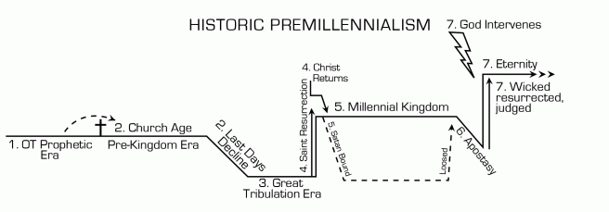
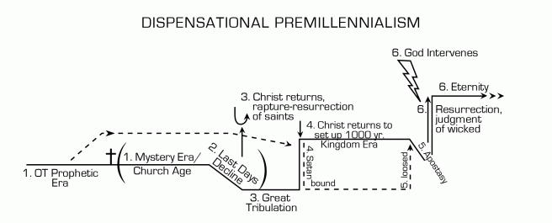
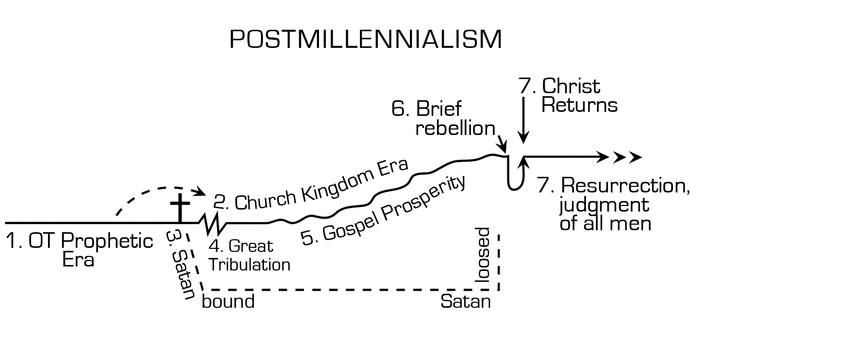
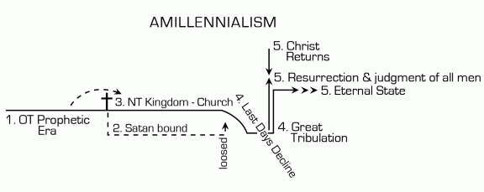
“Millennium” is Latin for “one thousand years” and here refers to a period in which certain people “came to life, and reigned with Christ a thousand years. The rest of the dead did not come to life until the thousand years were ended.”
- Popularized by John Nelson Darby (1830 AD)

- Main view of Baptists
- OT prophecy & Revelation is interpreted literally.
- Millenium is literal and Christ reigns on Earth.
- Israel & Church are separate
- Popularized by Alexander Campbell (1788 AD).
- Main view of Liberation Theology & liberal protestants
- Millenium is not literal. Christ reigns through the Church
- Israel & OT prophecy fulfilled in Church
- Popularized by Augustine (400 AD).
- Main view of Catholics, Lutherans, Reformed, and Anglicans.
- Millenium is not literal. Christ reigns from Heaven.
- Israel & OT prophecy fulfilled in Church.
- Popularized by Justin Martyr (165 AD).

- Millenium is literal or at least a future period in which Christ reigns on Earth.
- Israel & OT prophecy fulfilled in Church & millennium.

Why bother with eschatology (study of the end times)?
- To provide hope and confirmation that in the end, God wins.
- To be aware of other views (especially when a popular view is proven wrong time and again)
- To avoid being misled by cults and others who use their views on prophecy to influence people

Key Terms:
- Eschatology: The study (Greek logos) of last things (Greek eschaton), i.e., the end of the world, the Last Judgment, the Second Coming of Christ, the resurrection of the body and, anything relating to the future.
- The Second Coming of Christ (also known as the Second Advent and the Return of Christ): Christ's physical return to earth, mentioned in such passages as Acts 1:11, 1 Thessalonians 4, and Hebrews 9:28.
- The Millennium: The thousand-year reign of Christ mentioned in Revelation, chapter 20. Premillennialists ("Chiliasts") believe in a literal thousand-year reign in the future. Amillennialists and postmillennialists believe that the thousand years is a figurative number for the entire period from Christ's first coming until His second.
- Premillennialism (Also known as Chiliasm from the Greek word for "thousand"): The belief that the Second Coming of Christ occurs before the millennium, which is a literal 1000 years. The resurrection of Christians occurs at the beginning of the millennium, the resurrection of the unsaved at the end of the millennium.
- Postmillennialism: The belief that the Second Coming of Christ occurs after the millennium. There is an increase in the spread of God's rule in every area of life during the millennium (a figurative concept referring to the entire Church Age).
- Amillennialism: The belief that the Second Coming occurs at the end of history, like postmillennialism, but there is no earthly millennium. The millennium is purely spiritual, applying only to heaven and the Church.
- Dispensationalism: The belief that history is divided into several distinct dispensations, or ages in which God relates to mankind in a different way. The most important distinction is between Israel's Age of Law on the one hand, and the Church's Age of Grace on the other. Dispensationalism is pretribulationist and premillennial. The Church Age ends and God's plan for Israel resumes when the Church is raptured at the beginning of the Tribulation. The millennium is Israel-centered: It rules over all other nations and animal sacrifices are performed in the Temple as in the Old Testament.
- The Great Tribulation: The great judgment of God that is foretold in such passages as Matthew 24, Mark 13, Luke 21, and the Book of Revelation. The main events occur in the land of Israel.
- The Last Days: Most believe that these are the days of great evil before the Great Tribulation. Some believe that the Last Days refers to the entire New Testament/Church period.
- The Rapture: The physical resurrection of believers, both living and dead, who will meet Christ in the air at His Second Coming. The word "rapture" is a transliteration of the Latin translation of the word found in 1 Thessalonians 4:17 and translated in English as "caught up."
- Futurist interpretation of the Tribulation: The Great Tribulation is yet to come.
- Preterist interpretation of the Tribulation: The Tribulation already occurred in 70AD (fall of Jerusalem by Rome).
- Church Historicist interpretation: The Tribulation is experienced by the Church throughout its history.
- Pretribulation (Pretrib) Rapture: The rapture occurs before the Tribulation. (The standard Dispensational view). A seven-year period (the 70th week of Dan 9:25-27) containing the reign of the Anti-Christ just prior to the millennium; restoration of Jews to Israel, conversion of the remnant of Israel, temple rebuilt, priesthood, sacrifices restored.
- Midtribulation (Midtrib) Rapture: The rapture occurs in the middle of the Tribulation. Variation in Dispensational view)
- Posttribulation (Posttrib) Rapture: The rapture occurs after the seven years of the Tribulation. (Historic premillennialist view).

Sources:
Images Courtesy of PJ Wenzel: https://disciplesforlife.org/2014/11/29/millennial-charts-of-the-four-major-views/
Definitions courtesy of Christian Classics Ethereal Library: http://www.ccel.org/contrib/exec_outlines/end/end_01.htm

